HMV Skilled Courses Hub organized Online Inaugural session for CPBFI in collaboration with ‘Bajaj Finserv’
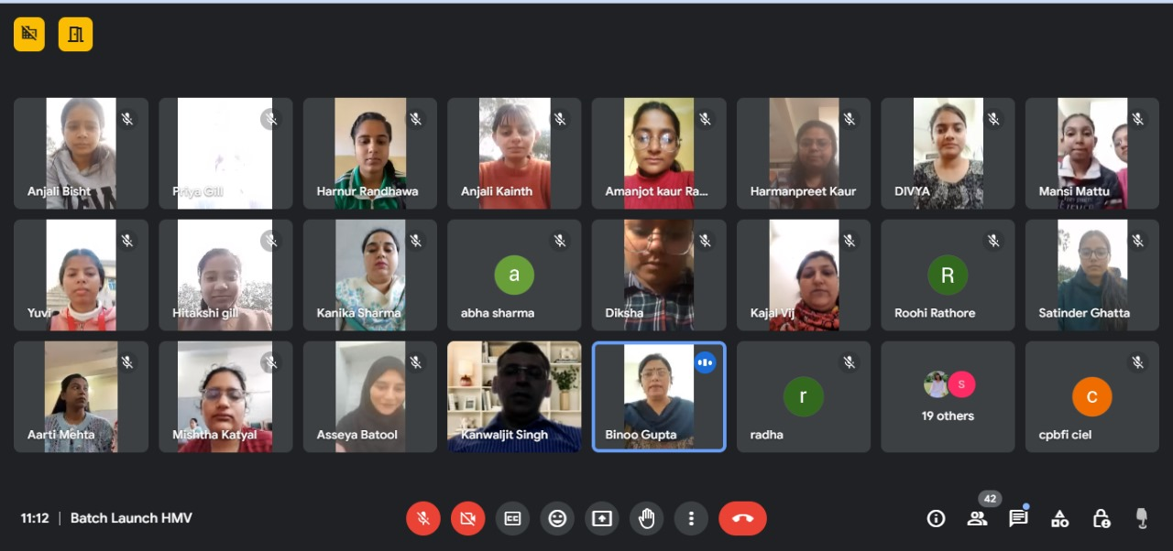
HMV Skilled Courses Hub of Hans Raj Mahila Maha Vidyalaya, Jalandhar organized Online Inaugral session for 100 hours Short-term course in Certificate Programme in Banking, Finance and Insurance (CPBFI)-2024 in collaboration with ‘Bajaj Finserv’ under the able guidance of Principal Prof. Dr. (Mrs) Ajay Sareen. The resource persons of the session were Mr. Kanwaljit Singh, Lead Trainer of Punjab Cluster of Bajaj Finserv Limited joined the session. Mrs. Meenu Kohli (Head, PG Department of Commerce), Mrs. Binoo Gupta, Dean Student welfare (Incharge, Commerce Club and Co-ordinator of course), Dr. Kajal Puri and Mrs.Kanika Sharma (Incharges of the course) presented green greetings to the resource person. Mrs. Binoo Gupta (Incharge, Commerce Club and Co-ordinator of course) told that aim behind conducting this session was that CPBFI is a core component of Bajaj Finserv employability initiative, aimed at making graduates employable for Banking, financial services and insurance industry which inter links with the beliefs of our institution i.e to impart the kind of education that enables women to become responsible, self-sufficient and independent. Mr. Kanwaljit Singh, Lead Trainer emphasized on the need of emotional quotient, stress management, effective communication and other such skills, apart from the formal degree, in the present banking & insurance industry. He briefed the students about course content and SWAROOP sessions and other practical training exposures during the course. Principal Dr. Ajay Sareen appreciated the efforts for taking this employability initiative and told students that dedication reaps rewards and more can be achieved by extra hard work. Some hours training can reform your life. She thanked the resource faculty for their cooperation. The session ended with the vote of thanks by Mrs. Binoo Gupta (Incharge, Commerce Club and Co-ordinator of course). Dr.Kajal Puri (Incharge of the course)gave formal vote of thanks to the resource persons and highlighted that the programme will be conducted in hybrid mode and will indulge unique feature like Managing Self, Overview of Retail Banking, Overview of Insurance and Communication and workplace Skill which is the need of the hour.

